**Personal loans**

Personal loans are a popular financial product in the U.S. banking sector, offering individuals a way to borrow money for a variety of purposes, such as consolidating debt, financing home improvements, covering medical expenses, or funding major purchases.

**Key Features of Personal Loans**

1. **Fixed vs. Variable Rates**:
   * **Fixed-Rate Loans**: Interest rate remains the same throughout the loan term, providing predictable monthly payments.
   * **Variable-Rate Loans**: Interest rate can fluctuate based on market conditions, potentially changing the monthly payment amount.
2. **Unsecured vs. Secured Loans**:
   * **Unsecured Loans**: No collateral required; approval is based on creditworthiness and income.
   * **Secured Loans**: Require collateral (e.g., savings account, car); typically offer lower interest rates due to reduced risk for the lender.
3. **Loan Amounts and Terms**:
   * Loan amounts can range from a few hundred to tens of thousands of dollars.
   * Repayment terms typically range from 12 to 84 months, depending on the lender and loan amount.
4. **Interest Rates**:
   * Interest rates vary based on credit score, loan amount, and term length.
   * Rates generally range from around 5% to 36%.
5. **Fees**:
   * **Origination Fees**: A percentage of the loan amount, deducted from the loan disbursement.
   * **Late Payment Fees**: Charged if payments are not made on time.
   * **Prepayment Penalties**: Fees for paying off the loan early (though many lenders do not charge this).

**Benefits of Personal Loans**

* **Flexibility**: Can be used for a variety of purposes.
* **Fixed Payments**: Easier to budget with predictable monthly payments.
* **No Collateral Needed**: Unsecured loans do not require collateral, making them accessible to more people.
* **Debt Consolidation**: Can combine multiple debts into a single loan with a potentially lower interest rate.

**Considerations and Limitations**

* **Credit Requirements**: Higher credit scores generally qualify for better rates and terms.
* **Interest Costs**: Higher interest rates compared to secured loans or other forms of credit, especially for those with lower credit scores.
* **Impact on Credit Score**: Taking out a loan and making regular payments can improve your credit score, but missed payments can harm it.
* **Fees**: Additional fees can add to the cost of the loan.

**Examples of Personal Loan Providers:**

• **SoFi**

* **Features**: No fees (origination, prepayment, or late fees), fixed and variable rate options, loan amounts from $5,000 to $100,000.
* **Benefits**: Competitive rates, unemployment protection, member benefits like career coaching.
* **Considerations**: Requires good to excellent credit.

• **Marcus by Goldman Sachs**

* **Features**: No fees, fixed rates, loan amounts from $3,500 to $40,000.
* **Benefits**: Flexible payment dates, on-time payment reward.
* **Considerations**: Requires good credit.

• **Discover Personal Loans**

* **Features**: No origination fees, fixed rates, loan amounts from $2,500 to $35,000.
* **Benefits**: Flexible repayment terms, 30-day money-back guarantee.
* **Considerations**: Requires good credit.

• **Avant**

* **Features**: Loan amounts from $2,000 to $35,000, available to those with fair to good credit.
* **Benefits**: Quick approval process, flexibility for lower credit scores.
* **Considerations**: Origination fees, higher interest rates for lower credit scores.

• **Light Stream (a division of SunTrust Bank)**

* **Features**: No fees, fixed rates, loan amounts from $5,000 to $100,000.
* **Benefits**: Low rates for excellent credit, rate beat program.
* **Considerations**: Requires very good to excellent credit.

**Graph representation**

• **Loan Amount Range**: Minimum and maximum loan amounts offered by different lenders.

• **Interest Rates**: Typical APR ranges based on credit scores.

• **Fees**: Comparison of origination fees and other common fees.

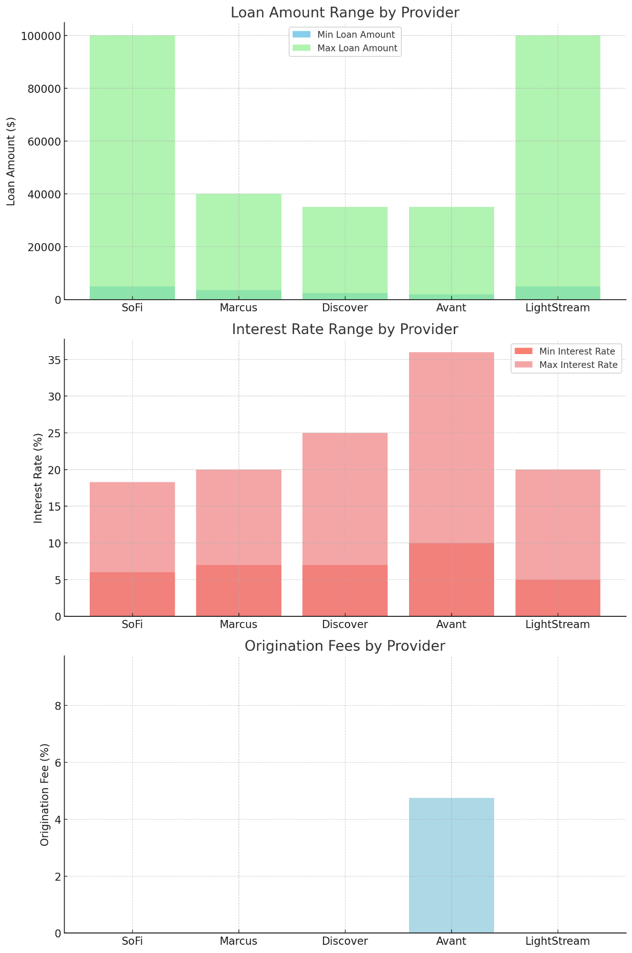

• **Loan Amount Range by Provider**:

* Shows the minimum and maximum loan amounts available from each provider.
* SoFi and Light Stream offer the highest maximum loan amounts ($100,000), while Avant offers the lowest minimum loan amount ($2,000).

• **Interest Rate Range by Provider**:

* Illustrates the range of interest rates based on credit scores.
* Light Stream offers the lowest minimum interest rate (4.99%), while Avant has the highest maximum interest rate (35.99%).

• **Origination Fees by Provider**:

* Highlights the percentage of the loan amount charged as origination fees.
* SoFi, Marcus, Discover, and Light Stream do not charge origination fees, while Avant charges a fee of up to 4.75%.

**Key Statistic:**

**Personal Loan Market Overview**

1. **Market Size and Growth**:
   * As of 2023, the total personal loan market in the U.S. was valued at approximately $156 billion.
   * The market has experienced significant growth over the past decade, with a compound annual growth rate (CAGR) of around 15%.
2. **Average Loan Amount**:
   * The average personal loan amount in the U.S. is approximately $8,000.
3. **Interest Rates**:
   * Average interest rates for personal loans range from 10% to 28%, depending on the borrower's credit score.
   * Borrowers with excellent credit can secure rates as low as 5.99%, while those with poor credit may face rates up to 36%.
4. **Loan Terms**:
   * The typical loan term for personal loans ranges from 24 to 60 months.
   * The most common loan terms are 36 and 60 months.
5. **Credit Scores**:
   * Approximately 60% of personal loan borrowers have credit scores in the range of 660 to 780.
   * Borrowers with credit scores below 600 account for about 20% of the personal loan market.
6. **Usage of Personal Loans**:
   * Debt Consolidation: Around 40% of personal loans are used for consolidating debt.
   * Home Improvements: About 15% of personal loans are used for home improvement projects.
   * Major Purchases: Approximately 10% of personal loans are used to finance major purchases, such as appliances or furniture.
   * Medical Expenses: Around 10% of personal loans are used to cover medical expenses.

**Delinquency Rates**

* The average delinquency rate for personal loans (defined as loans 90+ days past due) is around 3%.
* Delinquency rates are higher for subprime borrowers (those with credit scores below 600), reaching up to 15%.

**Market Players**

* **Top Personal Loan Providers** (by market share):
  + **SoFi**: Known for low fees and competitive rates.
  + **Marcus by Goldman Sachs**: Offers flexible payment terms and no fees.
  + **Discover Personal Loans**: Provides a money-back guarantee and no origination fees.
  + **Avant**: Caters to borrowers with lower credit scores and quick approval processes.
  + **Light Stream**: Offers low rates for excellent credit and no fees.